**CYBER PHYSICAL SYSTEMS - ADVANCES AND APPLICATION**

**CHAPTER-6**

**CYBER PHYSICAL SYSTEMS IN AUTONOMOUS AND UNMANNED AERIAL VEHICLES**

**Sindhu Rajendran*, Shreya S, Alaska Tengli, Ramavenkateswaran N**

*Department of Electronics and Communication*

*R. V. College of Engineering Bangalore-560059*

*India*

* Email: [sindhur@rvce.edu.in](mailto:sindhur@rvce.edu.in) ,*Contact No. : +91-9538351009

**ABSTRACT:** In today’s world demand for autonomous and unmanned aerial vehicles is rapidly growing with applications in many domains. These autonomous vehicles have potential advantages like – reduction in traffic deaths by 90%, drop in harmful emissions by 60%, improvement in fuel economy by 10%, increase in lane capacity by 500%, reduction in travel time by 40%, increase in transportation accessibility and reduction in transportation costs. Similarly, UAVs have advantages like- traffic monitoring, moving objects in seemingly dangerous environments, payload delivery and surveillance. Cyber Physical Systems (CPS) are combinations of networking, computation and physical systems. The three interacting components of CPS - communication, computation, control and their coupling effects are necessary for improving the performance of the UAV network. Control mechanisms, performance and safety of autonomous and unmanned aerial vehicles are the important factors to be considered while designing them.The major concern for any fully or partially autonomous system is safety, the other challenges faced are-mechanical failure, communication bandwidth shortage, cyber-hacking, communication delay, etc. Various designs are proposed and tested to overcome these challenges, few of them are: a framework for software - ReMinds in addition with the extensions implemented in the Dronology system; for Dronology, researchers have proposed and designed incubators for safety-critical CPS. The chapter emphasizes the role of CPS in autonomous and unmanned aerial vehicles, framework of CPS for UAVs, the challenges with respect to CPS and is concluded with the state of art of the present autonomous vehicles.

**Keywords**: Autonomous vehicles,computation,Component based Design,Controller area network, Cyber Physical System (CPS),cyber security, Data driven strategy, Dronology, Embedded systems,Model Based Design,networking,Physical Processes, ReMinds, Safety, sustainability,transportation,UAVs

**INTRODUCTION:**

# A cyber-physical system (CPS) combines computing with physical processes, and the behavior of the system is determined by both the computational and physical components. Embedded communications and devices continuously track mechanical phenomena, which typically involve feedback where computations are impacted by physical processes and vice versa. The Internet of things and the industrial internet are examples of embedded systems. Modern cars, fly-by-wire airplanes, medical gadgets, electricity production and dissemination techniques, robots, building control systems, distribution systems, and many more are examples.

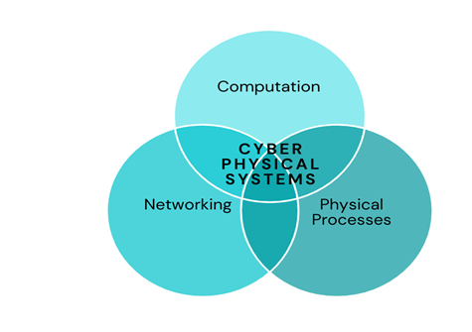

**Figure : 1** Venn Diagram Depicting Cyber Physical System

The junction of the physical and digital worlds—not their union—represents the conceptual challenge of CPS. Separately designing, analyzing, and comprehending the computational and physical components, and then connecting them, is insufficient. We need to comprehend and plan for the interplay of various components, such as computing, connectivity, and physical processes, in order to enable their integration.

Although cyber-physical systems have been present for a while, the field has just lately come together as an academic study. Because of this, there aren't currently established design methodologies for CPS that are backed by tools as there are for, say, digital circuit design, even if there are methods and tools for automating CPS design in some domains.

CPS are also multidimensional and more complicated than integrated circuits. There is no unique "design space" for Cyber physical systems like there is for digital systems, as seen by the consistency inside the making challenges for many CPS purposes that really come from the combination of specific properties. The CPS of today bridges the real and virtual worlds, equipment and software, actuators and sensors.

They are also frequently large-scale, increasingly dispersed systems. They must be adaptable since they must function in extremely dynamic contexts and for constantly changing goals. Finally, because many CPS work alongside human operators, the human element of their design must be carefully taken into account. For the community of design automation, this demand represents a substantial potential. Every stage of the design process is covered by the opportunity, including specification, designing, language layout, software, simulation, testing and evaluation, analysis equivalence and precision verifying, surveying, performance process optimization, user interfaces, routing algorithms, testing, bug fixing, treatment plan, as well as fixing, and other.

We believe that each of these examples need further development in conceptual model, methods, and equipment where there is need to make the architecture of CPS as regular and their conduct as expected as the planning and installation of digital circuits are at the moment. We demand new design methods for CPS that have an effect equivalent to the register transfer level(RTL) design flow for digital systems. Additionally, the rising accessibility of data on system design and field usage increases the possibility of developing new design techniques for CPS. In this work, we place more emphasis on an explanation of a fundamental approach that has been thoughtfully chosen than outlining the various specific prospects for systems engineering of CPS.

**1.1 Evolution Of Autonomous Vehicles:**

Numerous industrial sectors, including the automotive industry, mining, machinery, etc., are actively researching the development of automated driving technology. New autonomous driving assistance system features and functions are continually being developed by the car industry. By the end of this decade, completely autonomous driving is the general goal. Many automakers, like Tesla, Ford, and others, have stated recently that they would have completely autonomous driving vehicles very soon, but they have frequently had to push back their stated timelines.The most well-known autonomous driving projects are Apple's self-driving vehicle project and Waymo from Google[1]. However, the problems involved have been more than first anticipated, and as a result their efforts have been hindered and the deadlines are prolonged.

Autonomous mobile robots have been tested and used by businesses in the manufacturing sector and warehouse logistics to enhance the functionality and efficiency of industrial processes. The networked and automated systems with seamless connection are a key component of the Industry 4.0 and Industry 5.0 evolution ideologies. As part of the Industry 4.0 idea, several researchers have concentrated on the incorporation of AV shuttles into industrial operations. The difficulties facing all of these autonomous driving and car development initiatives are largely the same. When building and deploying autonomous cars, functional safety and cybersecurity are frequently the key issues.

A brand-new mode of transportation designed to close the last-mile public transit gap is the automated vehicle (AV) shuttle. Most autonomous (SAE level 4) low-speed mini buses are used as AV shuttles. This indicates that the cars operate inside a predetermined operational domain and are totally automated, free of any on-board human control systems[2].

The operational design domain establishes the boundaries for the operational environment in which the vehicle is intended to function, including the location, the kind of weather and road conditions, the speed limit, the volume of traffic, etc. Starting with the design and development stage and continuing through the deployment and services stage, safety is the primary concern and is given top concern throughout the whole development process.

Fully automated driving systems (without human supervision) are still not permitted on public streets alongside urban traffic, despite rapid advancements in autonomous driving. Due to the necessity of taking into account/understanding numerous complex factors, such as the environment, traffic, the dependability of hardware and software systems, the availability of information, cyber security, etc.Safety is a major concern for any fully or partially autonomous driving system. As an illustration, experts from several automakers have established twelve principles that prioritize characteristics of safety and security.

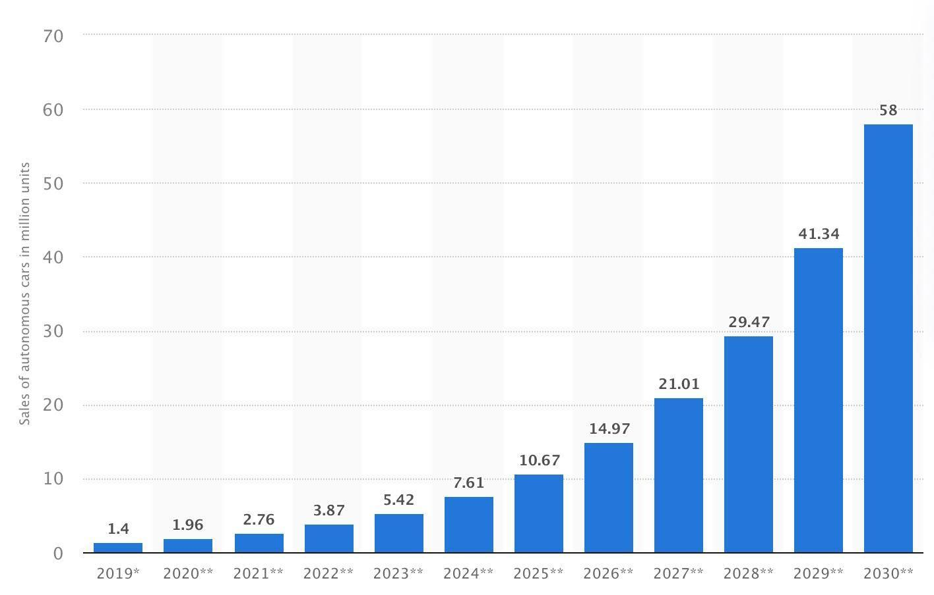

**Figure 2 :** The anticipated global sales of autonomous cars from 2019 to 2030. (in million units). (Published in Statista on April 22, 2021 by Martin Placek) The sales of driverless vehicles are predicted to rise between 2019-30. According to predictions, 1.4 million vehicles sold globally in 2019 feature at least Level 3 autonomy. Around 58 million of these automobiles are anticipated to be sold globally in 2030[3].

**1.3 Introduction To Unmanned Aerial Vehicles (Uavs):**

An UAV is an airplane without a human pilot on board, often known as an unmanned aerial vehicle / unmanned aircraft (UAV) [4]. Due to recent and ongoing developments, commercialized applications for Uav in everyday activities have increased, including aerial images, delivery services, and disaster response. UAVs’are considered cyber physical systems because they combine computer intelligence, such as drones fulfilling missions in the real world might need physical mechanisms like on-board navigation systems and a ground control station (GCS)[5]. Hardware, software, and the outside environment all have feedback loops. For instance, the software must adapt to its environment to avoid encountering humans or other obstacles.

A thorough safety investigation or official verification is typically required for concerns relating to safety, particularly with regard to UAVs and CPS. Real Time tracking has shown to be successful in identifying and stopping improper activity. Numerous runtime monitoring techniques have been proposed, each with a different focus [6].

For example, requirements monitoring can check whether systems behave as expected, execution verification can spot observed behavior but also possibly take action, and quality control can gather information on the virtual servers used by the measured response [7].

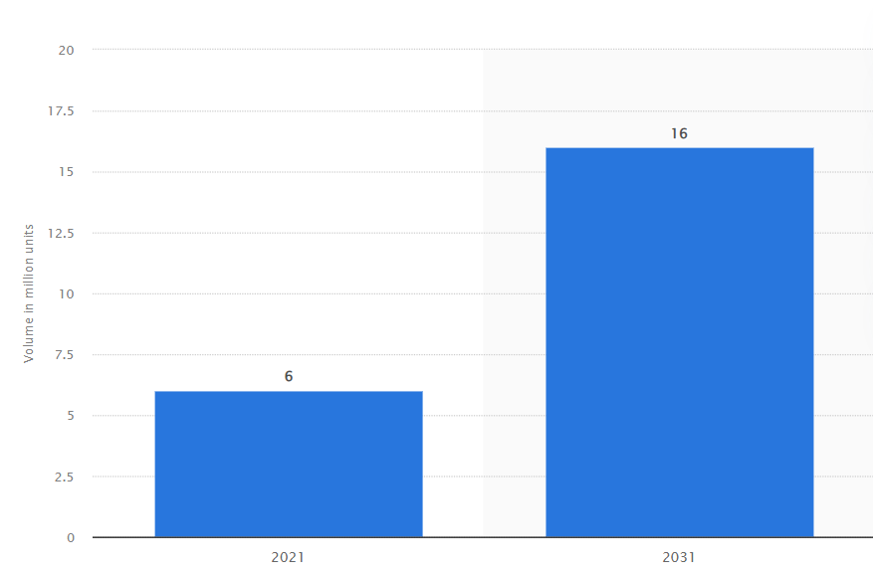

**Figure 3 :** The volume of the commercial unmanned aerial vehicle (UAV) industry for the years 2021 and 2031. (in million units). **(**Commercial drone market size in the globe in 2021 and 2031, Federica Laricchia published this on February 14, 2022)

The commercial drone or unmanned aerial vehicle (UAV) market has grown significantly in recent years and is predicted to reach six million units by 2021. It is estimated that 16 million of such drone technology would be marketed globally by 2031.

## **IMPORTANCE OF CPS:**

Successful cyber-physical system design and construction will help solve numerous national goals in fields that traditional computer science cannot, such as aviation, manufacturing, crisis response, medical services, manufacturing, and municipal administration. Innovators will be encouraged, economic viability will be improved, and systems will be able to become more efficient and consume less resources thanks to standards, procedures, and analytical system's fundamental elements. Cyber-physical systems have several benefits, one of which is the acceleration of technical advancement, which has a favorable impact on many different enterprises, sectors, and eventually, millions of lives.

Standards that specify functional safety and features that help avoid accidents in emergency situations are now required due to technological advancements and growth in the automobile industry, particularly with the advent of automated and driver-assist systems. By providing functions, functional safety is a technique for lowering risks to a manageable level and ensuring safety.

In order to handle all the information created in virtual representations or cyber versions of the actual world, Industry 4.0 evolution demands significant degrees of digitalization. A critical element of the integration of these two worlds is the modular cyber-physical system (CPS). The three basic categories of modules that interact with the physical environment are sensors, actuators, and computing units. In order to establish some sort of global behavior, mobile modular CPS is often constructed as a network and has a lot of processing power to maintain positioning, obstacle detection, safety features, and path following[8].

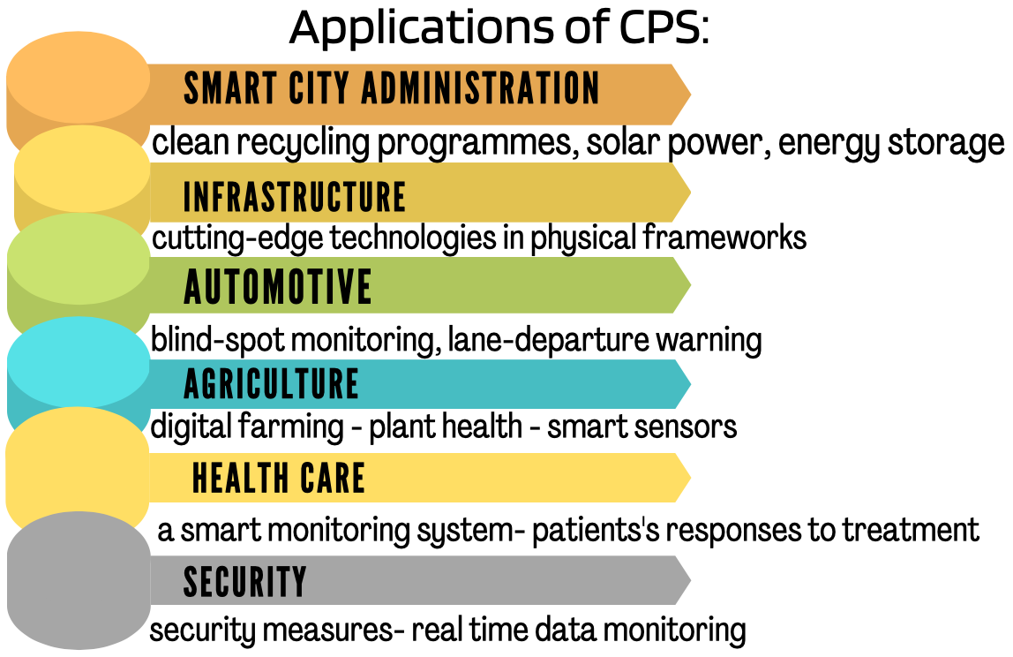

**Figure - 4** Application of Cyber Physical System

**2.1 Advantages Of Cps:**

Cyber-physical systems (CPS) are intimately linked hardware and software platforms that enable the large scale, closed loop administration or control of advanced, complicated dynamical systems. Data is necessary for the operation of effective cyber-physical systems. A CPS can reliably complete unmanned aircraft systems , especially tiny ones, used for actual monitoring, management, control, and actuation operations unmanned aircraft systems (SUAS). In this chapter, a variety of studies of SUAS biosensor CPS scenarios are provided. These scenarios enable adaptive management and efficient control of complex physical systems, including the distribution of water precise measurements of crop evapotranspiration and soil moisture, the tracking of fish using radio stickers, the production of alternative energy, the mapping of invasive plant species, and the tracking of airborne feathers (environmental damage). This chapter includes inspiration for potentially widely used UAS technologies.Understanding the effects and advantages of technology for cyber-physical systems across several industries .The few examples of how many sectors have prospered from CPS technology :

* ***Smart-city administration***: According to TechTarget, a "smart city" is a municipality that uses information and communication technology to improve its efficiency, exchange information to the public, and enhance both the quality of federal services and citizen welfare.

The utilization of cyber-physical systems technology is crucial in the development, implementation, and optimizing of smart cities. A complex ecosystem known as a "smart city" includes systems important to smart transportation planning, disaster response technology, and services for emergency responders.[9]

* ***Infrastructure*** : Developing Technology is where infrastructure improvement begins. IoT sensors and video cameras, as well as other cutting-edge digital technology, are used by
* sustainable cities to enhance the experience of locals, businesses, and government workers. In order to upgrade the various out-of-date systems of city infrastructure, CPS engineers must become experts in cutting-edge technology. Critical infrastructure may be upgraded more often when cutting-edge technologies are introduced to physical frameworks
* ***Automotive***: IoT and CPS technology have accurately advanced smart automobiles that do random monitoring, driveway warning, and the forward collision warning are just three of the

smart car technologies that, if implemented in all automobiles in the United States, may reduce the frequency of collisions and, as a result, save millions of dollars annually.[8]

* ***Agriculture*:** Already recognised as smart agriculture or digital farming, CPS-related technology has led to advancements that help farms run more smoothly, from drones and satellites that relay images related to plant health to smart sensors on tractors or harvesters that disclose information on soil type and condition.

### ***Sustainability***: Society is constantly having to look for ways to tackle the imperative a numerous industries, including business, healthcare, and others, must adopt renewable sources. These solutions continue to evolve thanks to CPS methods;; initiatives like clean recycling programmes, accessible solar power, affordable energy storage, and public electric logistics too are made possible as a direct result of cyber physical systems and internet of things

* ***Security and privacy***: A number of techniques have been added to security measures as a result of the development of smart technology. CPS technology has enabled smart security to progress and improve, from mobile app development for real-time remote monitoring to complete new intelligent remote monitoring [10]

### ***Health care****:* The development of numerous medical advancements have been made possible via cyber physical technology. As a result of research and development, the field of health care has improved significantly, from a smart monitoring system that tracks patients' responses to therapy to a smart continuous device that transmits messages on glucose concentrations to the user's mobile.

**CHALLENGES WITH RESPECT TO C:**

Lack of project platforms to investigate open problems, offer solutions, and thoroughly assess them is a barrier to study on Cyber physical Systems. As a result of the following traits together, cyber-physical systems face special design challenges:

• Hybrid: Computational and physical systems (CPS) are interconnected. In order to understand mixed systems that integrate both discrete and ongoing features, appropriate theory and skills are required for the modeling, building, and analysis of CPS.

• Multidisciplinary: Because a CPS system's components come in a variety of shapes and sizes, it entails interface and interoperability across diverse computing platforms.

• Distributed: In today's cyber-physical systems, parts can be physically and/or temporally separated and are often networked.

• Large-scale: As measured by the number of basic components a system consists of, the mass of cyber-physical systems is expanding quickly, resulting in a swarm of interconnected sensors, actuators, compute, and communication devices that generates vast amounts of information.

* Dynamic: The CPAs environment is always changing, hence the system's design and operation must take this constantly changing environment into consideration.

Additionally, the environment may act in an aggressive manner by deliberately attempting to violate intended system characteristics.

• Adaptive: The CPS must adjust to a changing environment, maybe online. In order to adapt to a changing environment, the system could use machine learning. Thus, the line separating both run-time and layout time becomes hazy.

• Human-in-the-loop: A number of cyber physical systems work in tandem with people by interacting with people and human-controlled devices in their surroundings or using human operators. In semi-autonomous vehicles and robotic surgical equipment, for instance, auto driverless controllers must interact with pedestrians and other road users. The function and interface with the human in the loop should always be considered when creating such systems [11].

**3.1 Steps That Can Be Taken To Overcome The Mentioned Challenges:**

These traits could appear to be very dissimilar from one another. But in our perspective, how these traits combine in actual systems poses the biggest design difficulties for CPS. For instance, one must take into account that advanced driver assistance systems (ADAS) in cars include machine learning components and are hybrid technologies that operate in an active environment and engage with people. The concerns that come from this combination must be handled by the design tools. To guarantee that the developed mechanisms are trustworthy, safe and impressive performing, the automation testing community must therefore develop theories, methodologies, and tools for something like the design of CPS with the specified

mix of attributes.. A design automation process with the following combination of elements is required for this challenge:

• Cross-domain: CPS must inevitably employ cross-domain design techniques since they are hybrid and diversified. The mechanical components of a robot's motions, as well as the electrical and software components, all require co-simulation techniques. • Based on components .The only method to handle growing complexity, according to the expanding vastness of CPS, is to execute architecture in a modular manner. It is crucial to create collections of replaceable, validated components with explicit service contracts. For this an element, service agreement design requires the right tools.

• Educational: The growing volume of CPS data and the demand for adaptive and dynamic environments-handling systems demonstrate the necessity for the system based on data driven learning. Anyways such learning is combined with formal techniques that may ensure proper functioning as well as principled model-based design. A critical future requirement is the creation of such learning-based design machines.

• Time-awareness: One of the fundamental elements tying the digital and physical worlds together is time. To understand the joint dynamics of these components, one must create a suitable temporal abstraction that correctly portrays the combined evolution of the computing and networking components of a CPS.

Numerous CPS are dispersed, which adds another layer of difficulty and could alter how different system components perceive time. CPS software applications are time conscious and have the right extraction to streamline the design process.

• Trust-conscious: Decentralized systems that operate in hostile, dynamic environments must consider fundamental trust-related issues while developing the system. Prior until now, security and privacy were secondary factors; however, CPS now prioritizes these issues while designing. The cyber physical component of technologies is also posing new confidentiality difficulties. Threat modeling, designing for them, and system security practices are all skills that design automation tools must possess.

• Human-centric: It is evident that design automation tools for CPS are required. If that is

taken into account both the manual element of design and that of the methods being created. The equipment must encourage man's invention by automating the tedious methods of work while yet allowing individuals to voice their opinions[1]. Similarly, it is crucial to provide tools to aid in the modeling, designing, and verification of such systems given the rising significance of human-in-the-loop CPS in daily life [11].

**ROLE OF CPS IN AUTONOMOUS VEHICLES:**

**4.1 Design Prospects Of Cps In Autonomous Vehicles**

Although autonomous vehicles (AVs) have attracted much interest and funding in the past few years, practical deployments do not appear likely any time soon. Modern autonomous cars are deeply integrated with computer vision techniques due to their capacity to recognize objects in a variety of visibility circumstances. The fundamental components of CPS design mechanization are listed below. Every path calls for the development of a distinct set of characteristics, and each route marks a substantial departure from the established paradigms for design automation.

They address distinct but related aspects of manufacturing CPS designs, therefore they shouldn't be considered as mutually incompatible. In addition, a highly feasible choice for data synthesis and analysis is a model-based and data-driven method. Systems with humans in the loop may be evaluated and created using many techniques.

* ***Model based design (MBD)*** Under the model based design (MBD) paradigm, high level models are initially created and then utilized to direct future engineering, simulations, verification, and validation for the proposed system.MBD has been applied in the field of embedded devices commercially, especially in aviation and automotive applications.[1] Prioritizing abstract, numerical simulations as a first step before digging into the implementation's finer features is the goal of the MBD approach. The presence of such models, along with the associated structured (numerical) definition of desired or undesired behaviors, can solve modeling and confirmation design phase, removing errors in the system's logic while the expenditure of detecting and resolving them is yet low and also improves the system's total dependability. [3]
* Cyber-physical systems of today must be reliable and adaptable. To increase reliability, formal methods and computational proof approaches may be used more easily when using a model-based approach. A **data-driven strategy** makes adaptability easier by using the data to inform decisions. Both strategies are necessary for cyber-physical systems that function in dynamic, ambiguous surroundings and safety- or mission-critical circumstances.
* ***Human-in-the-loop system****:* A number of cyber-physical systems interact with one or more people, and the human function is essential to the system's proper operation.[1] A human in the cyber physical system is the name of the entire system (h-CPS). [6] In the Industrial domains that these systems serve, the costs of improper operation might be quite high. Studies have shown that human factors are frequently to blame for failures or almost failures.

***Two basic elements are necessary for these systems to operate effectively*:** interfaces between human generator(s) and autonomous components, and The fundamental difference between an h-CPS and a fully autonomous system is the requirement for control sharing in an H—CPS due to the presence of one or more human operators.

As a consequence, the human in CPS model must include both a picture of the operator in human form and a component that acts as a liaison between them and the autonomous controller. If an autonomous controller or a person should be in charge of the plant is determined by an autonomous controller. Three agents make up a person-in-the-loop controller: one autonomous, one operator, and one advisory . A human in the loop system's design, in a circumstance whenever an automatic mode is required, the controlling advisor will transmit the appropriate advisory to a user interface like audio/video interface. When the driver sees this indication, they may take over and provide the car the control inputs. Upon a successful handoff, the advisory manager tells the automatic part of the portion by transmitting which is no longer in charge of managing the plant.

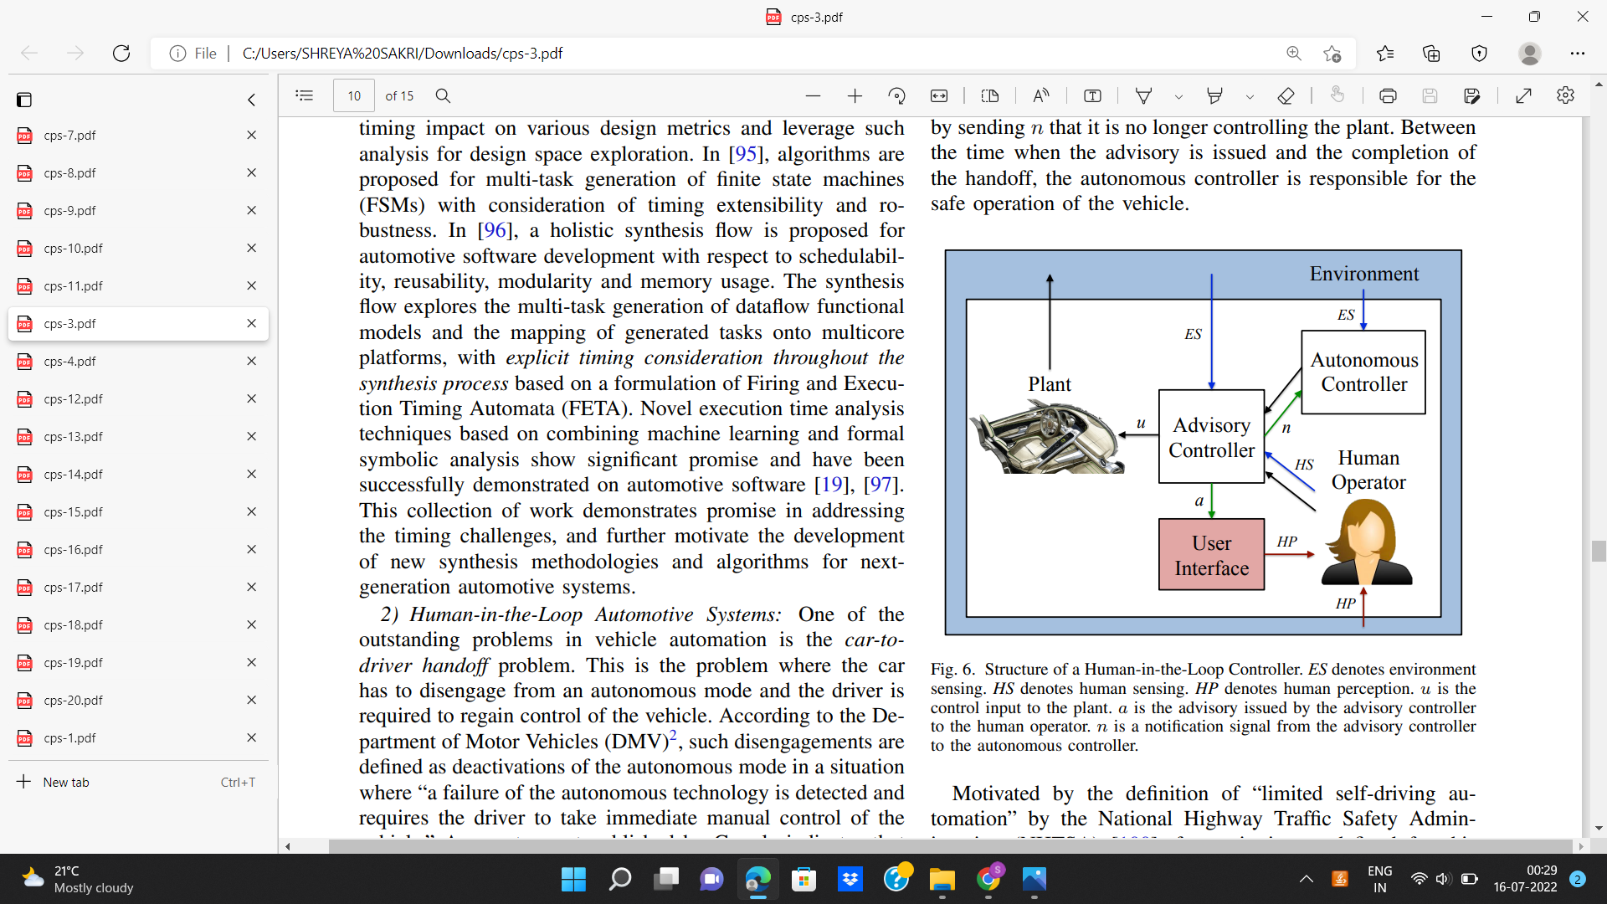

**Figure 5:** Controller Structure [3]

Environment sensing stands for ES. HS stands for human sensing. Human perception is designated by HP. The plant's control input is u. A is the advice given to the human operator by the advisory controller. The notification signal n is sent to the autonomous controller by the advisory controller [3].

* ***Component-based design* -** One of the key achievements in electrical design automation is the register transfer logic (RTL) for digital circuit design. The RTL flow places a strong focus on component-based design, which is a crucial factor. More RTL source modules, an innovation library, more hardware gate and state-holding components, etc. are only a few examples of the many abstraction levels at which this paradigm is used.

Thankfully, there are some new design techniques that can be used as a foundation. Platform-based design looks for the best combination of platform components to satisfy an application's needs by mapping a bottom-up propagation of platform limits along with a top-down application of authentication and authorization restrictions. Contract-based design adds a strict concept of written contracts to the PBD technique to ensure that the composition of components fulfills desired traits [1].One can develop the appropriate library of components, compositional rules, and interface contracts; these approaches offer a structure for component-based design.

* ***Design for Security & Privacy*** *-*Today, two of the most crucial design considerations for cyber-physical systems are security and privacy. In a wide sense, security refers to the condition of being safe from danger. Being kept out of sight is the condition of privacy. Security and privacy issues are becoming a top priority for system designers. Systems that are embedded or computer security are increasingly networked with one another and the Internet[1] Privacy and security have elevated to a critical concern for automotive systems due to the increased intelligence and connection of vehicles. By breaking into an automobile's engine management system, braking process control, and other electrical components, the creators were able to risk a production model [12].

Attacks are performed utilizing reverse engineering, packet sniffing, targeted probing, fuzzing, and internal Controller Area Network (CAN) buses. CAN is now the most popular protocol and, regrettably, the one that attackers find most attractive. To offer message authentication, Message Authentication Codes (MACs) have been added to CAN data frames using a variety of methods. It can be difficult to include security measures without impeding safety and control applications due to CAN bus capacity and message length limits, especially if security was not originally planned for.

**4.2 Aspects of CPS in the present era**

The automobile industry now has some of the most pressing CPS issues. In particular, **self-driving** autos—sometimes referred to as ADAS, or advanced driver assistance systems, have evolved from research/study prototypes to readily accessible automobiles during the previous ten years. These systems have been incorporated into medium to high end cars.

They can currently automate tasks like parallel parking, lane maintenance, and moving through stop-and-go traffic. These technologies are being incorporated into medium- to high-end vehicles and are already equipped to automate duties like lane maintaining, stop-and-go traffic navigation, and parallel parking. The performance and security of a driverless car in the long term, however, are also questioned by these new technologies.

It could take a few more decades before self-driving cars become commonplace, because of several engineering, legal, and policy considerations. The design of combined human automated control has several scientific and mechanical hurdles, although semi-autonomous driving is now a reality. These factors make the semi-autonomous driving industry a promising one for CPS design.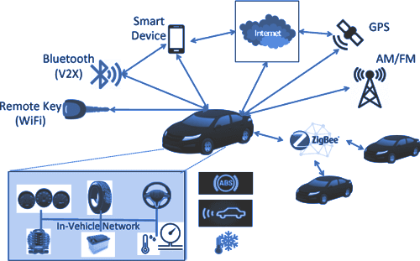

**Figure -6** Autonomous industry assistance system.

**4.3 Future Prospects Of Cps**

The further distribution and interconnected design systems are being adopted, as well as the increased functional complexity in size and features, have made the architecture and practice of automobile electronic subsystems more difficult. Between 2000 and 2010, the cost of developing automotive software climbed from 2 to 13 percent of the entire value of a car, while the number of code lines rose from 1,000,000 to over 10,000,000.

Over the past ten years, many electronic control units there have been observed to increase in automobiles from 20 to beyond 50. The conventional federated design, where every function is deployed to a single specified ECU, is evolving to integrate design, where one task may disperse across many electronic control units and multiple tasks can support ECU. In order to accommodate expanding functionality and lower system costs, there is also a trend toward the deployment of multi core ECUs (by minimizing the amount of ECUs and connecting cables in the system). Due to such tendencies, there is a lot more sharing and competition over the architectural platform across software functions.

The future of automotive innovation will be dominated by software and electronics. According to estimates, software and electronics were used in around 90% of automotive advancements in 2012, particularly in active safety and entertainment systems. Given the rapid development of autonomous driving technology, it is expected that this trend will continue in the years to come. Given this tendency, the sophistication of vehicle digital circuits will continue to increase fast. This necessitates the need for complex design and execution solutions.

These findings are only the beginning. There are still numerous issues that need to be resolved, such as increasing the scale by another order of magnitude, managing dynamic, uncertain, and hostile situations, working with nonlinear dynamics, and inferring appropriate logical characterizations of motion primitives. Nevertheless, it's crucial to recognize that the beginning presentation represents a fortunate execution of the architecture intent.

**ROLE OF CPS IN UNMANNED AERIAL VEHICLES:**

**5.1 Present State Of Art Of Cps In Uavs**

CPS has played an important role in many sectors, the following are the design prospects in unmanned aerial vehicles

***1.ReMinds:***

The UAV system works by building a closed loop, which involves the initial data perception, exchange of information, higher cognitive process, and therefore the ultimate execution. A cyber physical system (CPS), that has gained considerable attention recently, may be seen from this aspect as the complex UAV network. ReMinds was developed to handle characteristics like decentralization, support for several platforms, requirements that are constantly evolving and being deployed, as well as diverse, ambiguous, and dynamic elements. Additionally it has the ability to manage various kinds of event-based constraints. In earlier research, supervising the automation software was preferred over working with plant hardware like cranes, vehicles, or robots[13].

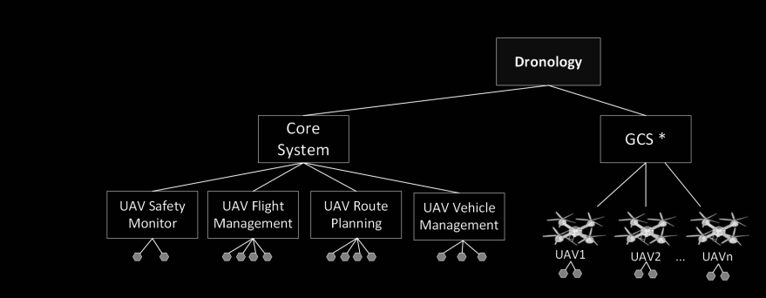

**Figure 7-** Model depicting the Monitoring areas of the Dronology [14]

ReMinds is applied to a UAV system designed for UAV operation in a particular area.Specifically, a study system was the Dronology research incubator. Several UAV flights can be managed, tracked, and coordinated using Dronology's detailed work environment. The system offers tools for allocating missions and managing numerous different UAVs at once. Additionally, it serves as a full-featured, extremely realistic Software-in-the-Loop (SITL) simulator that permits testing with fictitious unmanned aerial vehicles (UAVs) and allows it to communicate with real hardware (the flying physical UAVs). A specialized GCS manages orders and messages delivered to and received from the UAV and manages both physical and virtual UAVs. Dronology can manage numerous GCS simultaneously and permits interaction between real and virtual UAVs in the same airspace. Metallurgical plants and UAVs are both CPS, although they differ in a lot of aspects. The major difference is that in the context of UAVs, numerous drones primarily operate independently (even while they will cooperate to accomplish a joint purpose and obstacle avoidance). Researchers looked at these as well as other domain-specific difficulties to assess whether ReMinds might have been updated and extended to operate in a whole different CPS space. Recent works have made the aforementioned contributions: I extended ReMinds management software to be utilized with a UAV CPS, (ii) analyzed UAVs CPS features to examine monitoring challenges specific to UAVs CPS, and (iii) evaluated the practicality and scalability of our method by tracking several simulated UAVs and proving its efficacy [13].

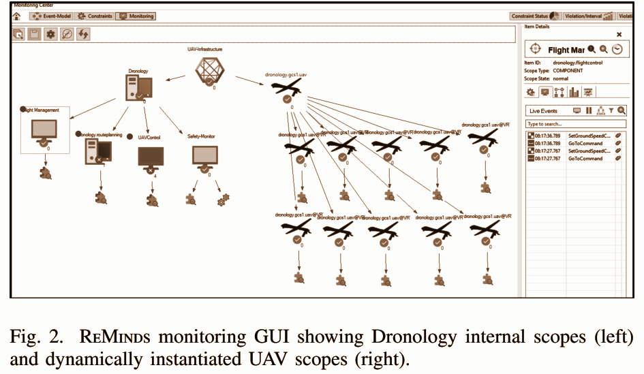

**Figure 8 -** Dronology internal scopes(left) and dynamically created UAV scopes(right) are displayed in the ReMinds monitoring GUI [13].

The ReMinds framework has five levels, of which one can be used to control variation while the other four are built for various components of the monitoring process. In contrast to the Views layers of the architecture, which permit the occurrence of arbitrary system-specific probes and monitoring tools for various domains and technologies, Compilation & Deployment and Computation & Assessment levels are independent of the individual systems to be observed. Applications that ingest and analyze events and data, as well as probes that send events and data tracked from multiple systems, gather and distribute data at an event broker, which acts as a central hub.The framework for ReMinds was influenced by the Necessities Monitoring Model (RMM). The following SoS monitoring components are included in the model: Monitoring Scopes, which specify the regions to be examined, represent the SoS design and, to some extent, the organization's structure of the SoS hierarchically.

***2. Cps Research Incubator:***

A system and its project environment for organizing and managing the flight of tiny unmanned aerial systems serve as the foundation of the research incubator for small unmanned aerial systems (CPS) (sUAS). The research incubator, which makes numerous, good project artifacts produced over many generations of a safety-critical CPS available, serves as a substitute for community resources. In a fully-executable runtime environment that supports combined physical and high-fidelity sUAS simulations, it enables researchers to test their own original concepts. Early contributors from the software engineering community have shown broad and passionate support for the project and its function as a testing ground for new ideas. They have also declared their intention to use the environment to address their own areas of research of goal modeling, runtime adaptation, safety, and software evolution.

The following requirements must be met in order for a project to qualify for the CPS research incubator:

* A cyber-physical component;
* The use of readily available and affordable hardware;
* Accessibility to a wide community of researchers in accordance with the required domain expertise;
* The addition of a variety of challenging hazards associated; and
* Advancement in accordance with the standards appropriate for medium criticality projects.

Dronology, a Java-based framework, is currently being created for controlling, directing, observing, and coordinating sUAS flight operations in urban airspace. It merges physical unmanned aerial systems (sUAS) and a high-fidelity Software-in-the-Loop (SITL) simulator through a Python-based ground station and is compatible with ArduPilot-based1 sUAS [4].

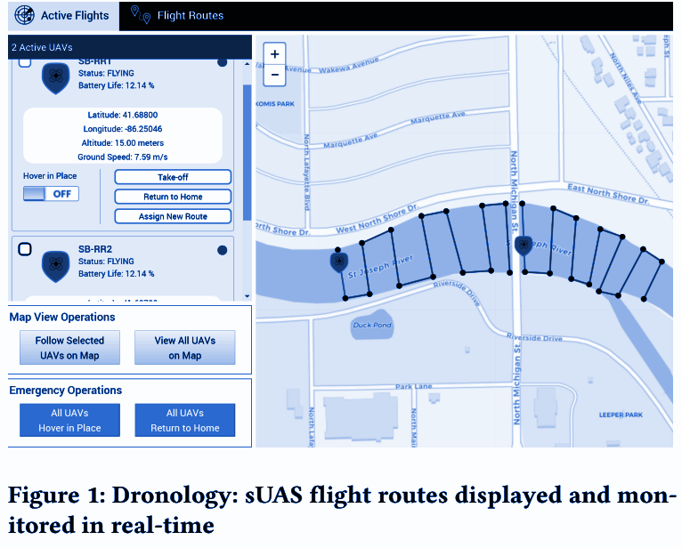

**Figure 9-** Dronology: real-time monitoring and display of sUAS flight routes[4]

The current datasets used by mining software repositories researchers:

* Open Source Systems
* Existing Community Datasets
* Industry Datasets[15]

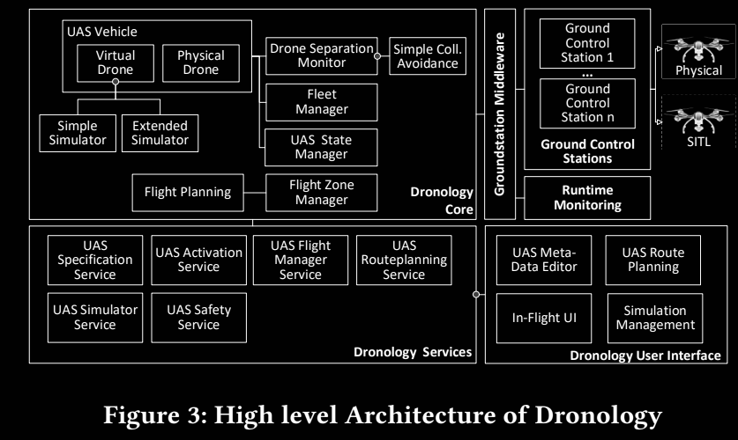  **Figure 10-** Advanced Dronology Architecture [4]

The following six topic categories discuss features of the Dronology incubator that can be helpful for each field's research:

• Requirements on Software and Systems

• CPS Product Lines

• Software Traceability

• Safety Assurance

• Runtime Adaptation and Monitoring

• Research on Humans

There are some limitations that must be considered. Using Java and Python as our main implementation languages, for instance, may limit Dronology's appropriateness for several real-time, crucial CPS research domains, which means that Dronology does not currently describe a system with actual real-time features [4].

**5.2** **Future Prospects Of Cps In Uavs**

Experimental results show that ReMinds can provide real time CPS monitoring, event collecting from diverse hardware and software components, and possibly constraint verification. The Dronology system has these features in place. Future studies will strive to support the outcomes of constraint evaluation in influencing the behavior of UAVs. We'll also improve the way that monitoring information for various CPS components is shown.

Researchers have proposed Dronology like a search camber which is safe. In the future, the following activities will be carried out:

(1) Continuous development of various characteristics to be forwarded across various copies;

(2) A line of products with numerous variance points and assets to be delivered at both the domain and application level;

(3) Study resources to enable survey challenges identified by the community, by organizing artifacts as easily customized and downloadable data sets and

(4) An unusual operational support system where contributors will provide both study resources and assets [4].

It offers a smart project environment with a variety of artifacts appropriate for a security-sensitive area. The incubator's goal is to support researchers working in CPS fields where there aren't enough conditions for experimental projects. Dronology is intended to be a community project, and partners are encouraged to work with us to create this lasting, valuable resource.

**CONCLUSION:** All of the literature that follows in this chapter focuses on finding answers to Innovation, ease of use, and safety are the three main concerns for any totally or partially autonomous system. Other difficulties include mechanical failure, a lack of communication bandwidth, cyber-hacking, communication delays are also being taken care of in order to provide an efficient system etc**.** Few strategies were discussed for cyber physical systems in Autonomous Vehicles - Model-based design (mbd) ,data-driven using the data to enhance the decision making ,component based ,security and privacy based . All of these are necessary for the system to operate in dynamic, uncertain environments and under safety or in critical missions which require solutions. The designs for cyber physical systems in unmanned aerial vehicles—the experimental findings revealed that the ReMinds, along with the upgrades made to the Dronology system, can effectively check constraints and supervise the CPS at runtime based on events gathered from various hardware and software elements. Future work may include adding support for UAV behavior adaptation based on the findings of constraint evaluations and enhancing the presentation of monitoring results for various CPS components.

**REFERENCES:**

[1] S. A. Seshia, S. Hu, W. Li and Q. Zhu, "Design Automation of Cyber-Physical Systems: Challenges, Advances, and Opportunities," in IEEE Transactions on Computer-Aided Design of Integrated Circuits and Systems, vol. 36, no. 9, pp. 1421-1434, Sept. 2017, doi: 10.1109/TCAD.2016.2633961.

[2] S. P. Mohanty, "Advances in Transportation Cyber-Physical System (T-CPS)," in IEEE Consumer Electronics Magazine, vol. 9, no. 4, pp. 4-6, 1 July 2020, doi: 10.1109/MCE.2020.2986517.

[3]"Design Automation of Cyber-Physical Systems: Challenges, Advances, and Opportunities," IEEE Transactions on Computer-Aided Design of Integrated Circuits and Systems, vol. 36, no. 9, september 2017, pp. 1421–1434, doi: 10.1109/TCAD.2016.2633961.

[4] J. Cleland-Huang, M. Vierhauser and S. Bayley, "Dronology: An Incubator for Cyber-Physical Systems Research," 2018 IEEE/ACM 40th International Conference on Software Engineering: New Ideas and Emerging Technologies Results (ICSE-NIER), 2018, pp. 109-112.

[5] H. Pikner, R. Sell, J. Majak, and K. Karjust, “Safety System Assessment Case Study of Automated Vehicle Shuttle,” Electronics, vol. 11, no. 7, p. 1162, Apr. 2022, doi: 10.3390/electronics11071162..

[6] Haijun Wang, Haitao Zhao, Dongtang Ma, and Jibo Wei “A Cyber Physical System Framework for UAV Communications” https://arxiv.org/abs/2005.06101[Submitted on 13 May 2020].

[7] H. Wang, H. Zhao, J. Zhang, D. Ma, J. Li and J. Wei, "Survey on Unmanned Aerial Vehicle Networks: A Cyber Physical System Perspective," in IEEE Communications Surveys & Tutorials, vol. 22, no. 2, pp. 1027-1070, Second Quarter 2020, doi: 10.1109/COMST.2019.2962207.

[8] Cyber physical systems role in manufacturing technologies Cite as: AIP Conference Proceedings 1957, 050007 (2018); https://doi.org/10.1063/1.5034337 Published Online: 19 April 2018 A. R. Al-Ali, Ragini Gupta and Ahmad Al Nabulsi.

[9] I. Jawhar, N. Mohamed and J. Al-Jaroodi, "Networking and communication for smart city systems," 2017 IEEE SmartWorld, Ubiquitous Intelligence & Computing, Advanced & Trusted Computed, Scalable Computing & Communications, Cloud & Big Data Computing, Internet of People and Smart City Innovation (SmartWorld/SCALCOM/UIC/ATC/CBDCom/IOP/SCI),2017,pp.1-7, doi:10.1109/UIC-ATC.2017.8397563.

[10] Ethical Aspects of Cyber-Physical Systems- European Parliament-PE 563.501 ISBN 978-92-823-9428-1 doi: 10.2861/68949 QA-01-16-635-EN-N.

[11] Borzoo Bonakdarpour, Jyotirmoy V. Deshmukh ,Miroslav Pajic “Opportunities and Challenges in Monitoring Cyber-physical Systems Security” ISBN:978-3-030-03426-9 DOI:10.1007/978-3-030-03427-6 Nov 2018.

[12] Trembley, Daniel K., "Cyber-physical embedded systems with transient supervisory command and control: a framework for validating safety response in automated collision avoidance systems" (2018). *Graduate Dissertations and Theses*. 39. <https://orb.binghamton.edu/dissertation_and_theses/39>.

[13] M. Vierhauser, J. Cleland-Huang, S. Bayley, T. Krismayer, R. Rabiser and P. Grünbacher, "Monitoring CPS at Runtime - A Case Study in the UAV Domain," 2018 44th Euromicro Conference on Software Engineering and Advanced Applications (SEAA), 2018, pp. 73-80, doi: 10.1109/SEAA.2018.00022.

[14] M. Vierhauser, J. Cleland-Huang, S. Bayley, T. Krismayer, R. Rabiser and P. Grünbacher, "Monitoring CPS at Runtime - A Case Study in the UAV Domain," 2018 44th Euromicro Conference on Software Engineering and Advanced Applications (SEAA), 2018, pp. 73-80, doi: 10.1109/SEAA.2018.00022.

[15] Stojcsics D, Boursinos D, Mahadevan N, Koutsoukos X, Karsai G. Fault-Adaptive Autonomy in Systems with Learning-Enabled Components. Sensors (Basel). 2021 Sep 11;21(18):6089. doi: 10.3390/s21186089. PMID: 34577296; PMCID: PMC8470782.

[16 ] Etter, W., Martin, P., Mangharam, R. (2011). Cooperative Flight Guidance of Autonomous Unmanned Aerial Vehicles CPS Week Workshop on Networks of Cooperating Objects (CONET) April 11-14, 2011. Chicago, IL.

[17] S. Omid Shafiei et al., "Measurable Augmented Reality for Prototyping Cyber Physical Systems: A Robotics Platform to Aid the Hardware Prototyping and Performance Testing of Algorithms," in IEEE Control Systems Magazine, vol. 36, no. 6, pp. 65-87, Dec. 2016, doi: 10.1109/MCS.2016.2602090.